**Interfacing a temperature sensor TMP36 with Arduino UNO**

**TMP36 (temperature sensor) features:**

1. **Low voltage temperature sensor (2.7v-5.5v)**

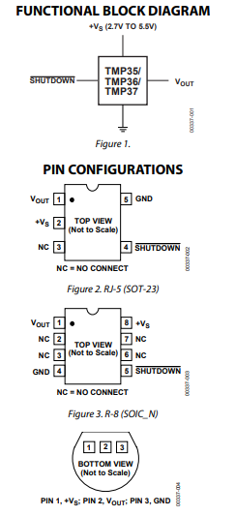

1. The TMP35 is functionally compatible with the LM35/LM45 and provides a 250 mV output at 25°C. The TMP35 reads temperatures from 10°C to 125°C. The TMP36 is specified from −40°C to +125°C, provides a 750 mV output at 25°C, and operates to 125°C from a single 2.7 V supply.
2. Calibrated to centigrade.

Formulas to turn the 10-bit analog reading into a temperature:

Voltage at pin in milliVolts = (reading from ADC) * (5000/1024)

This formula converts the number 0-1023 from the ADC into 0-5000mV (= 5V)

If you're using a 3.3V Arduino, you'll want to use this:

Voltage at pin in milliVolts = (reading from ADC) * (3300/1024)

This formula converts the number 0-1023 from the ADC into 0-3300mV (= 3.3V)

Then, to convert millivolts into temperature, use this formula:

Centigrade temperature = [(analog voltage in mV) - 500] / 10

//TMP36 Pin Variables

int sensorPin = 0; //the analog pin the TMP36's Vout (sense) pin is connected to

//the resolution is 10 mV / degree centigrade with a

//500 mV offset to allow for negative temperatures

/*

* setup() - this function runs once when you turn your Arduino on

* We initialize the serial connection with the computer

*/

void setup()

{

Serial.begin(9600); //Start the serial connection with the computer

//to view the result open the serial monitor

}

void loop() // run over and over again

{

//getting the voltage reading from the temperature sensor

int reading = analogRead(sensorPin);

// converting that reading to voltage, for 3.3v arduino use 3.3

float voltage = reading * 5.0;

voltage /= 1024.0;

// print out the voltage

Serial.print(voltage); Serial.println(" volts");

// now print out the temperature

float temperatureC = (voltage - 0.5) * 100 ; //converting from 10 mv per degree wit 500 mV offset

//to degrees ((voltage - 500mV) times 100)

Serial.print(temperatureC); Serial.println(" degrees C");

// now convert to Fahrenheit

float temperatureF = (temperatureC * 9.0 / 5.0) + 32.0;

Serial.print(temperatureF); Serial.println(" degrees F");

delay(1000); //waiting a second

}